EVACUATION PLAYBOOK

Evacuation Branch Director

Version: Fall, 2024
DECEMBER 2020
TABLE OF CONTENTS

How To Use This Playbook 1
1.0 Evacuation Branch DIRECTOR Evacuation Checklists 2
EVACUATION PRE-PLANNING CHECKLIST 3
EVACUATION BRANCH DIRECTOR – TACTICAL EVACUATION 5
EVACUATION BRANCH DIRECTOR – EVACUATION ALERT 6
EVACUATION BRANCH DIRECTOR – EVACUATION ORDER 9
2.0 Evacuation Management Zones 12
3.0 Evacuation Roles And Responsibilities 1
4.0 Evacuation Flow Chart 10
5.0 Evacuation COMMUNITY PARTNER List 11
6.0 Evacuation Decision Guidelines 12
Wildfire 12
Hazardous Materials Spill 12
General Method for Calculating Evacuation Triggers 13
7.0 Sample Evacuation Org Chart 14
8.0 MAPS 1

How To Use This Playbook

This evacuation playbook was created to help community leadership navigate the evacuation planning challenges commonly experienced during the critical first hour of evacuation response.

This document is not intended to replace the complete INSERT COMMUNITY NAME evacuation plan or operate as a stand-alone resource.

This guide consists of information relevant to the Evacuation Branch Director during the initial stages of a community evacuation. It includes the following information

               | Evacuation Branch Director Checklists  Evacuation Management Zones  Evacuation Roles and Responsibilities  Evacuation Flow Chart  Evacuation Stakeholder List  Evacuation Decision Making Guidelines  Sample Evacuation Branch Organizational Chart  Maps

1.0 Evacuation Branch DIRECTOR Evacuation Checklists

EVACUATION PRE-PLANNING CHECKLIST

Depending on the nature of the threat, it can be necessary to move some community members ahead of time in advance of an evacuation order. This can include elders, children, and/or people with transportation and/or medical challenges. It can be done under an EMCR task number when an evacuation alert is in place.

An EOC activation will likely be required to support the pre-emptive evacuation activities. All eligible costs associated with the EOC activation to plan and execute early evacuation of community members and domestic livestock can be covered through the EMCR task number.

- Confirm need to evacuate based on current status of event; consider recommendations from other response and support agencies and discuss their reasoning
- Activate your EOC in accordance with the Community Emergency Plan
- Confirm that there is an EMCR task number and if one hasn’t already been issued, call to request one: 1-800-663-3456
  - Provide best information on the nature of the event or threat, including how imminent it is
  - Best estimate of how many people and/or properties are threatened
  - Location and contact information for the EOC or primary community representative
  - Rationale and context around who and/or what domestic livestock needs to be evacuated early, why they need to be evacuated, and where they are going
  - Request any additional assistance you need through EMCR
  - Request an EMCR Coordination Call in the first hour
- Confirm number of community members, homes and facilities, and/or domestic livestock that are to be evacuated
- Chief & Council to declare State of Local Emergency; forward to EMCR regional office
- INSERT ADMINISTRATOR TITLE HERE to issue signed Evacuation Order; forward to EMCR regional office
- Initiate the evacuation order
  - Send copies to EMCR local region PREOC
  - Include geographic description and map of evacuation order area
  - Include geographic description and address of Reception Centre location(s)
- Notify all EOC members, support agencies and community partners that an evacuation order has been initiated
  - Confirm that ESS support and Reception Centre(s) are activating
  - Identify a member of Community Leadership to be a Liaison at the Reception Centre
- Activate your key public messaging to notify community members
  - Where to go
  - How to get there
  - What to do when they get there
  - How to notify the EOC where they’ll be staying and how to contact them once they’ve evacuated and registered

EVACUATION PRE-PLANNING CHECKLIST cont’d

- Activate signage on evacuation route(s)
- Activate area and community emergency access management plan as appropriate
- Activate community security plan as appropriate
- Activate Community Business Continuity Plan or consider business continuity priorities
- Activate regular communications protocol for critical information sharing across agencies as appropriate; consider
  - Daily or twice daily scheduled conference call with immediate evacuation support agencies
  - Daily EMCR coordination call
- Prepare a re-entry plan
  - Rapid damage assessment to identify which homes and facilities are safe to re-enter
  - Confirm areas that are safe for residents to return to, and when
  - Transportation needs
  - Communication to evacuated community members
  - Support for domestic livestock
  - Removal of evacuation route(s) signage
- Monitor the situation and consult with active agencies on expected duration of the threat
  - Consider the need for an extension on the evacuation order as appropriate and engage Community Leadership as required

Page 2 of 2

EVACUATION BRANCH DIRECTOR – TACTICAL EVACUATION

For additional guidance see EMCR’s Local Emergency Response Operations site.

- Ensure personal safety and the safety of your family
- Confirm the EMCR Task Number issued with the EOC Operations Section Chief
- Request any additional assistance required through the EOC Operations Section Chief
- Confirm with EOC Operations Section Chief:
  - Nature of the event or threat, including how imminent it is
  - Geographic area(s) under threat
  - Best estimate of how many people and/or properties are threatened
  - ESS Host locations (Internal / External Evacuation) have been activated
  - Evacuation Routes
  - Muster areas for residents requiring transportation
  - Residents with special transportation requirements
  - Known vulnerable populations estimate
    - Youth and elders
    - Residents with health considerations and special transportation requirements
  - Number of domestic pets
  - Number of domestic livestock and any special evacuation considerations
  - Facilities and locations for evacuated livestock

- Confirm the number of evacuees without vehicles needing transportation assistance
- Determine type and number of transportation vehicles required and request through Logistics Section Chief
- Confirm pertinent evacuation information with Information Officer
  - Designated muster areas
  - A transportation plan for residents without vehicles
- Consider the need for opening main corridors to maximize outbound lanes of traffic
- Discuss with MoTT the need for:
  - Maximizing outbound highway traffic flow (converting inbound lanes to outbound)
  - Pre-positioning traffic control assistance at key on/off ramp locations
  - Pre-positioning tow trucks along highway to clear large vehicle obstructions
- Review the Evacuation Management Zone Summaries
- Evacuate known vulnerable populations as appropriate
- Consider the need for livestock evacuation and how it may conflict with the evacuation of people
- Go to Evacuation Order or Alert checklist as appropriate

Page 1/1

EVACUATION BRANCH DIRECTOR – EVACUATION ALERT
For additional guidance see EMCR’s Local Emergency Response Operations site.

- Confirm the EMCR Task Number issued with the EOC Operations Section Chief
- Request any additional assistance you need through the EOC Operations Section Chief
- Confirm with EOC Operations Section Chief:
  - Nature of the event or threat, including how imminent it is
  - Geographic area(s) under threat
  - Best estimate of how many people and/or properties are threatened
  - ESS host locations (Internal / External Evacuation) have been activated
  - Evacuation Routes
  - Muster areas for residents requiring transportation
  - Residents with special transportation requirements
  - Number of domestic pets
  - Support agencies who need to be contacted and who will contact them
  - Evacuation status of known vulnerable populations
    - Known vulnerable populations estimate
      - Youth and elders
      - Residents with health considerations and transportation needs
      - Language considerations
  - Evacuation status of domestic livestock
    - Number of domestic livestock and any special evacuation considerations
    - Facilities and locations for evacuated livestock
- Review the Evacuation Management Zone Summaries

Consider the need for a Notification Group:
- Coordinate with RCMP:
  - Number of personnel required to assist with door-to-door notification
  - Brief personnel on notification protocols
- Coordinate community resources as required
  - Vehicles, flagging tape, evacuee information forms, etc.
  - Deploy and track resources
- Coordinate evacuation alert and personal preparedness key messaging with Information Officer

Page 1/3

EVACUATION BRANCH DIRECTOR – EVACUATION ALERT cont’d

Consider the need for a Traffic Management Group to coordinate with RCMP and MoTT:
- Review Evacuation Management Zone Summaries in the Community Evacuation Plan
- Identify traffic route assignments for evacuated areas using all available outbound lanes
- Prioritize evacuation by neighbourhood considering risk and population density
- Assign public works or a designate to secure all evacuation routes, helispots and muster areas as required
- Post route direction signs
- Consider the need for dynamic message signs to inform drivers of evacuation alert and where to check for up-to-date information
- Consider a designated inbound route for responders, tow trucks, and fuel trucks
- Assign traffic control personnel to potential traffic control/choke points (e.g., stop controlled left turns)
- Establish security checkpoints and intercept all inbound traffic; consider the need for police presence
- Assign patrols on traffic routes to clear stalled/broken down vehicles
- Consider the need to assign traffic control personnel to control flow onto highway entrance ramps
- Consider the need to pre-position towing services
- Monitor traffic patterns via on ground observations / traffic cameras and redirect flow as needed
- Consider the need for redirecting or closing sections of the highway to inbound travel
- Confirm pertinent evacuation information with Information Officer
  - Evacuation departure routes and reception centres
  - Designated muster areas for bus transportation
  - Any other key messaging

Consider the need for a Transportation Group
- Confirm the number of evacuees without vehicles needing transportation assistance
- Determine type and number of transportation vehicles required and request through Logistics Section Chief
- Confirm pertinent evacuation information with Information Officer
  - Designated muster areas
  - A transport plan for residents without vehicles
- Consider the need for opening main corridors to maximize outbound lanes of traffic
- Discuss with MoTT the need for:
  - Maximizing outbound highway traffic flow (converting inbound lanes to outbound)
  - Pre-positioning traffic control assistance at key on/off ramp locations
  - Pre-positioning tow trucks along highway to clear large vehicle obstructions
  - Evacuation messaging on dynamic highway signs to inform drivers of evacuation alert and where to check for up-to-date information (consult with Information Officer to confirm key messaging)

Page 2/3
EVACUATION BRANCH DIRECTOR – EVACUATION ALERT cont’d

Consider the need for a Security Group:
- Determine number of security resources required
- Request security resources through Logistics
- Give a briefing to the security resources and deploy them
- Review the 10-step Temporary Access Flow Chart
- Consider the need for a qualified escort(s) for all individuals/agencies passing-through an evacuated area
- Coordinate with RCMP to:
  - Pre-identify security checkpoints into evacuated areas
  - Strategically designate security checkpoints for temporary access into the evacuated area
  - Confirm temporary access procedures and coordinate system with the security resources on site
    - Confirm a reporting structure for checkpoint personnel to RCMP, contractors and the EOC as required
    - Establish a clear point of contact for both the checkpoint personnel and EOC for efficient communications
    - Identify to whom the EOC Master Lists will be sent and through what channel and identify how the completed/expired Master Lists will be returned to the EOC
(i.e., Master Lists may be emailed to RCMP detachment who then provides the Master Lists to their officers at the beginning of their shifts or emails/delivers the Master Lists to checkpoint personnel
  - Identify who the EOC Master Lists will be returned and when (i.e., email and at the end of each operational period)
    - Provide copies of the Temporary Access Permit Procedures handout
- Consider the need for additional Logistics to help support any ESS requests
  - Coordinate building access and any on site equipment required by the ESS group
  - Coordinate with Logistics any additional resources required (e.g., lighting, generators, sanitation, additional cleaning services, etc.)
  - Review host location parking plans
    - Assign personnel to supervise parking activities
    - Consider designated parking for Reception Centre support staff
- Consider the need for additional Logistics to help support the evacuation branch groups

Page 3/3

EVACUATION BRANCH DIRECTOR – EVACUATION ORDER

For additional guidance see EMCR’s Local Emergency Response Operations site.

- Ensure personal safety and the safety of your family
- Confirm the EMCR Task Number issued with the EOC Operations Section Chief
- Confirm an Evacuation Order has been issued by the Chief or issuing authority
- Request any additional assistance you need through the EOC Operations Section Chief
- Confirm with EOC Operations Section Chief:
  - Nature of the event or threat, including how imminent it is
  - Geographic area(s) under threat
  - Best estimate of how many people and/or properties are threatened
  - ESS Host locations (Internal / External Evacuation) have been activated
  - Evacuation Routes
  - Muster areas for residents requiring transportation
  - Residents with special transportation requirements
  - Known vulnerable populations estimate
    - Youth and elders
    - Residents with health considerations
  - Number of domestic pets
  - Number of domestic livestock and any special evacuation considerations
  - Facilities and locations for evacuated livestock
  - Support agencies who need to be contacted and who will contact them
- Review the Evacuation Management Zone Summaries
- Evacuate known vulnerable populations as appropriate
- Evacuate domestic livestock as appropriate

Consider the need for a Notification Group:
- Coordinate with RCMP:
  - Number of personnel required to assist with door-to-door notification
  - Brief personnel on notification protocols
- Coordinate, deploy and track community resources as required
  - Vehicles, flagging tape, evacuee information forms, etc.
- Coordinate evacuation alert and personal preparedness key messaging with Information Officer
- Collect the following updated information and share with the Planning Section:
  - Number and location of residents already evacuated
  - Number and location of residents evacuating
  - Number and location of residents refusing to leave
  - Number and location of residents requiring transportation assistance
  - Number and location of residents requiring special transportation assistance
Page 1/3

EVACUATION BRANCH DIRECTOR – EVACUATION ORDER cont’d

Consider the need for a Traffic Management Group to coordinate with RCMP and MoTT:
- Review Evacuation Management Zone Summaries in the Community Evacuation Plan
- Identify traffic route assignments for evacuated areas using all available outbound lanes
- Consider the need to prioritize evacuation by neighbourhood
- Assign public works or a designate to secure all evacuation routes, helispots and muster areas as required
- Post route direction signs
- Consider the need for dynamic message signs to inform drivers of evacuation alert and where to check for up-to-date information
- Consider a designated inbound route for responders, tow trucks and fuel trucks
- Assign traffic control personnel to potential traffic control/choke points
- Establish security checkpoints and intercept all inbound traffic; consider the need for police presence
- Assign patrols on traffic routes to clear stalled/broken down vehicles
- Consider the need to assign traffic control personnel to control flow onto highway entrance ramps
- Consider the need to pre-position towing services
- Monitor traffic patterns via on ground observations / traffic cameras and redirect flow as needed
- Consider the need for redirecting or closing sections of the highway to inbound travel
- Confirm pertinent evacuation information with Information Officer
  - Evacuation departure routes and reception centres
  - Designated muster areas for bus transportation
  - Any other key messaging

Consider the need for a Transportation Group
- Confirm the number of evacuees without vehicles needing transportation assistance
- Determine type and number of transportation vehicles required and request through Logistics Section Chief
- Confirm pertinent evacuation information with Information Officer
  - Designated muster areas
  - A transport plan for residents without vehicles
- Consider the need for designating an ingress first responder traffic route and the need for opening a multiple lane outbound traffic route for evacuees
- Discuss with MoTT the need for :
  - Opening highways to maximize multiple outbound lanes of traffic
  - Pre-positioning traffic control assistance at key on/off ramp locations
  - Pre-positioning tow trucks along highway to clear large vehicle obstructions

Page 2/3
EVACUATION BRANCH DIRECTOR – EVACUATION ORDER cont’d

Consider the need for a Security Group:
- Determine number of security resources required
- Request security resources through Logistics
- Give a briefing to the security resources and deploy them
- Review the 10-step temporary access flow chart
- Consider the need for a qualified escort(s) for all individuals/agencies passing-through an evacuated area
- Coordinate with RCMP to:
  - Pre-identify security checkpoints into evacuated areas
  - Strategically designate security checkpoints for temporary access into the evacuated area
  - Confirm temporary access procedures and coordinate system with the security resources on site
    - Confirm a reporting structure for checkpoint personnel to RCMP, contractors and the EOC as required
    - Establish a clear point of contact for both the checkpoint personnel and EOC for efficient communications
    - Identify to whom the EOC Master Lists will be sent and through what channel and identify how the completed/expired Master Lists will be returned to the EOC
(i.e., Master Lists may be emailed to RCMP detachment who then provides the Master Lists to their officers at the beginning of their shifts or emails/delivers the Master Lists to checkpoint personnel
Identify who the EOC Master Lists will be returned to and when (i.e., email and at the end of each operational period)
    - Provide copies of the Temporary Access Permit Procedures handout
- For temporary cross-jurisdictional access, instruct requestors to submit a copy of their form to each respective jurisdiction

Consider the need for a Reception Centre Group:
- Coordinate building access and any on site equipment required by the ESS group
- Coordinate with Logistics any additional resources required (e.g., lighting, generators, sanitation, additional cleaning services, etc.)
- Review host location parking plans
  - Assign personnel to supervise parking activities
  - Consider designated parking for Reception Centre support staff
- Consider the need for additional Logistics to help support the evacuation branch groups

Page 3/3

2.0 Evacuation Management Zones

Insert Maps and
Summaries Here

3.0 Evacuation Roles And Responsibilities

  - Site Level
POSITION | EVACUATION ROLES & RESPONSIBILITIES
INCIDENT COMMANDER  (IC) | Responsible for:  - The safety and evacuation activities of the responders involved at site level  - Providing information and recommendations to the EOC for when an evacuation alert, order or rescind needs to be issued  - If the emergency shows an immediate threat to the health and safety of people, the Incident Commander may initiate a tactical evacuation

  - Chief & Council
POSITION | EVACUATION ROLES & RESPONSIBILITIES
POLICY GROUP  (Comprised of the Chief and Council and the INSERT ADMINISTRATOR TITLE HERE) | Responsible for:  - EOC support, coordination and/or public engagement as requested by the EOC Director  - Providing policy direction and establishing priorities during all phases of an evacuation in consultation with the EOC Director and Subject Matter Experts  - Reports to the community
CHIEF | - Responsible for support activities for an evacuation event in the community  - Provides strategic guidance throughout the evacuation  - Not involved in EOC operations unless requested by the INSERT ADMINISTRATOR TITLE HERE or EOC Director  - Provides interpretation of existing policies, or develops new policies to address emerging situations  - Provides continuity of governance  - Typically acts as the Community Spokesperson (with assistance from the Information Officer)  - May declare a State of Local Emergency and any subsequent evacuation alerts, orders, and rescinds as appropriate (with assistance from the Chief and/or EOC Director)  - It is important the Chief and Council are seen by community members and the network of supporting agencies as a confident and cohesive unit  - Reports to the community  - See Chief & Council Evacuation Checklists
Community INSERT ADMINISTRATOR TITLE HERE | - Carries ultimate responsibility for the community evacuation  - Typically acts as EOC Director  - Reports to Chief during EOC activations  - See INSERT ADMINISTRATOR TITLE HERE Evacuation Checklists
EMERGENCY PROGRAM COORDINATOR | - Typically acts as the Liaison Officer between Chief, Emergency Management Committee, and the external agencies  - May act as EOC Director or Deputy EOC Director  - Reports to INSERT ADMINISTRATOR TITLE HERE  - See Emergency Program Coordinator Evacuation Checklists
COMMUNITY SPOKESPERSON | - This position may be designated to the Chief, Council Member, INSERT ADMINISTRATOR TITLE HERE, or Public Information Officer  - May become the “face” of the emergency throughout the response and recovery process  - Must remain calm and confident to reassure the impacted public  - Must be available to conduct media interviews which can take place at any time of the day  - Will speak on behalf of the Chief & Council in all media interviews (with assistance from the Information Officer)  - EOC Information Officer and EOC Director can provide support and factual information  - See Community Spokesperson Evacuation Checklists and Key Messaging

  - Emergency Operations Centre (EOC)
POSITION | EVACUATION RESPONSIBILITIES
EOC DIRECTOR | Responsible for:  - Oversight of the community evacuation during an EOC activation (the INSERT ADMINISTRATOR TITLE HERE has ultimate responsibility)  - Activating the EOC and the evacuation plan  - Ensuring the Chief & Council and government representatives are alerted and kept informed  - Working with the Operations Section Chief and the Evacuation Branch Director to develop evacuation strategies  - Initiating the early evacuation process for vulnerable populations and livestock during an Evacuation Alert  - Managing all aspects of the evacuation process  - Preparing for and coordinating Evacuation Alerts, Orders and Rescinds  - Identifying and notifying potential host communities and maintaining communication between host communities through the entire evacuation process  - May be responsible for one or several events at the same time  - Reports to Policy Group  - See EOC Director Evacuation Checklists
INFORMATION OFFICER | Responsible for:  - Confirming factual information for EOC Director approval before it is released to the public and other organizations  - Disseminating frequent, up-to-date, concise, and relevant information on the threat and evacuation activities to residents and the general public  - Disseminating information and instructions to residents, including:  - The specific areas affected  - List of items evacuees should take with them  - Communicating central muster areas for people requiring transportation assistance  - Simple instructions on evacuation routes  - Reception Centre locations  - Disseminating information and instructions regarding care for domestic pets and for domestic livestock evacuation  - See EOC Information Officer Checklists and Key Messaging
OPERATIONS SECTION CHIEF | Responsible for:  - Working with the EOC Director to develop evacuation objectives, strategies, and tactics  - Assessing the number and type of resources required to achieve the evacuation objectives  - Deploying and supervising evacuation resources  - Ensuring evacuation objectives are completed  - Sharing all evacuation updates with the Planning Section Chief  - Assuming the role of Evacuation Branch Director position unless designated to someone else  - Reports to EOC Director  - See EOC Operations Section Chief Checklists
EVACUATION BRANCH DIRECTOR | Responsible for:  - Working with the planning section to compile known information about affected populations, scope, and impacts  - Making evacuation strategy recommendations to the Operations Section Chief  - Work with ESS Team to identify Evacuation Reception Centre and Group Lodging locations and confirming the locations with the EOC team  - Collecting information on the status of evacuations  - Estimating traffic capacity of designated evacuation routes and preparing an evacuation traffic plan  - Coordinating with RCMP:  - Door-to-door evacuation notifications  - Selecting evacuation routes  - Preparing an evacuation traffic plan  - Estimating the time required to evacuate areas  - Identifying muster areas for people who do not have transportation; identify special transportation requirements  - Assisting with identifying facilities to receive evacuated animals  - Reports to Operations Section Chief  - See EOC Evacuation Branch Director Checklists
PLANNING SECTION CHIEF | Responsible for:  - Tracking and reporting the status on evacuation procedures:  - Evacuation notification, number of residents evacuated, number of evacuees in reception centre facilities, etc.  - Contributing traffic route maps to the Evacuation Traffic Plan  - Anticipating sudden event changes that may impact evacuation operations and logistics  - Supporting all aspects of evacuation planning, including Recovery and ESS  - Reports to the EOC Director  - See EOC Planning Section Chief Checklists
LOGISTICS SECTION CHIEF | Responsible for:  - Coordinating provisions for:  - Evacuation of an area (transport vehicles, barricades, signs, heavy equipment, etc.)  - Supporting evacuees (food, beds, clothing, water/water trailers, medical supplies, animal and pet supplies, sanitation services, lighting, generators, etc.)  - Setting up Reception Centres and/or Mass Shelters  - Activating mutual aid agreements  - Reports to the EOC Director  - See EOC Logistics Section Chief Checklists
FINANCE SECTION CHIEF | Responsible for:  - Tracking costs and the reimbursement process for evacuation activities  - Confirming the financial expenditure approval process with the Operations Section Chief and the Logistics Section Chief  - Confirming the EMCR EAF submission process with Logistics  - Reports to the EOC Director  - See EOC Finance Section Chief Checklists
EMERGENCY SUPPORT SERVICES  (ESS) | Responsible for:  - Working with EOC to determine locations of Reception Centres (RC) and Group Lodging (GL)  - Establishing and managing RC and/or GL facilities under direction from the EOC  - Collecting and coordinating evacuee support needs and services required  - Communicating resource needs to the EOC  - Dispensing essential supplies (e.g., food, water, beds, sanitation services, clothing, medical equipment, and supplies) to evacuees  - Providing regular situational awareness to the EOC and EMCR on a variety of topics (e.g., number of registrants, approximate value of referrals distributed, additional supports required, and the current status of operations)  - Evacuee Registration intake  - Typically reports to the Operations Section Chief (ESS Branch), but may report to the CHIEF or EPC instead

  - Provincial Government
AGENCY | ROLES & RESPONSIBILITIES
BCEHS  BC Emergency Health Service  (Formerly BC Ambulance Service) | - Responsible for medical aid to injured people  - Has a provincial agreement with LOCAL HEALTH AUTHORITY and may be requested to assist with the transportation of medically infirmed from facilities owned by health authorities  - During initial response stages, they may provide dedicated support to the responder agencies  - May provide a liaison to attend EOC as required
BCWS  BC Wildfire Service | - Responsible for leading the response to all wildfire operations on crown lands and on Reserve Lands by agreement with Indigenous Services Canada  - Provides recommendations to Local Authorities on Evacuation Alerts, Orders and Rescinds as it pertains to wildfires  - Assists with delineation and mapping for boundaries of recommended Evacuation Alerts and Orders  - May provide a dedicated community liaison to the EOC if requested  - WILL NOT PUT OUT STRUCTURE OR VEHICLE FIRES  - Will provide sprinkler protection units and personnel for protection work around structures and critical infrastructure
EMCR  Ministry of Emergency Management & Climate Readiness | - Provides an EMCR Task Number for tracking purposes; this is necessary for any cost reimbursements from the Province  - Facilitates connection to supporting and assisting agencies  - Can provide financial support, secure additional resources (through resource requests and expenditure authorization for critical resources i.e., transportation services, security, and physical blockades)  - Upon request from the community EOC, they will host a multi-stakeholder coordination call starting in the first hour after the event has initiated and then scheduled as required  - May rebroadcast Chief & Council social media posts and website information  - It can be beneficial to request that an EMCR Regional Manager attend the EOC in person for the first few operational periods  - Accesses provincial volunteer resources (i.e., Search and Rescue, ESS Mobile Support Team, Provincial Emergency Radio Communications Service, PEP Air, Road Rescue) as required  - Coordinates any national and international supports required for impacted communities  - May review and provide feedback on evacuation plans  - May provide expertise and assistance with evacuation route planning, re-entry planning, and recovery planning upon request
MoF  Ministry of Forests | - May provide subject matter expertise  - Issues advisories and provides forecast updates through River Forecast Centre (RFC)  - Communicates with Local Authorities, other relevant authorities on flood mitigation works  - Can provide technical subject matter expertise to natural resource management and reforestation  - May provide expertise for support to rural economic development recovery  - May provide a liaison to attend EOC as required
FNHA Health Emergency Management  First Nations Health Authority | - Supports First Nation communities to respond to emergency events  - May provide First Nations communities with support and essential services through existing programs for wellness and health emergency management in First Nations communities  - This may include resources such as potable water testing, air quality testing and access to health care  - May provide subject matter expertise to and/or environmental health staff to support re-entry planning and rapid damage assessment for First Nations communities  - May provide a liaison to attend EOC as required
HEMBC / PHSA  Health Emergency Management BC / Provincial Health Services Authority | - Provides leadership to health sector  - Responsible for providing health services and care to existing patients and clients  - Evaluates the risk to affected communities and moves patients to health care facilities in other communities, as appropriate, usually during the Evacuation Alert stage  - Tracks outpatients during evacuations (those receiving home care, outpatient treatments, etc.) and makes certain outpatients are continuing to receive specialized treatments in host communities  - Provides psychosocial support to evacuees through the Disaster Psychosocial Services (DPS) program  - Prior to an Evacuation Rescind being issued by the EOC, Health Authorities work to re-establish key health services  - During re-entry, Health Authorities utilize appropriate health programs to provide public health advice and guidance (e.g., how to address houses contaminated by mold or freezers filled with rotten food)
LOCAL HEALTH AUTHORITY | - Maintain a network of hospitals, clinic and first aid posts in rural areas  - Has a provincial agreement with BCEHS to transport the medically infirm from their facilities during an evacuation; confirm with LOCAL HEALTH AUTHORITY that this extends to their home stay clients  - Can provide technical subject matter expertise to support re-entry planning  - Provide liaison to attend EOC as required
ISC  Indigenous Services Canada | - Has a legal mandate for the public safety of on-reserve community members, which they extend through an agreement with EMCR to provide emergency management support services  - May provide funding for unusual expenses not typically covered through the Provincial legislation for First Nations communities
MoEP  Ministry of Environment and Parks | - Monitors, augments, or takes over the response to hazardous materials (hazmat) incidents related to evacuations on provincial crown land  - Provides technical advice to EOCs, Chief & Council fire departments or Public Works  - Identifies and evaluates immediate risks and impact on environment, human health, or infrastructure and as necessary advises agencies or parties to take protective action (i.e., shelter-in-place and evacuations) in the context of hazardous spills  - Declares a State of Environmental Emergency when required  - Orders response or recovery actions to protect the environment and human health  - May provide subject matter experts for advance planning support for hazardous materials management and natural resource management in EOC on a temporary basis
MIRR  Ministry of Indigenous Relations and Reconciliation | - May provide community liaison services if requested and applicable  - May provide support to consultation activities related to longer term recovery  - May provide program support & expertise to economic recovery activities; may or may not have funding sources
MoTT  Ministry of Transportation and Transit | - Works closely with First Nations, local authorities, and Police of Jurisdiction during the pre-planning of an Evacuation concerning traffic route selection, capacity and conditions and ensuring that all detours are viable for all types of traffic  - Provides assistance with proposed messaging to public through DriveBC about alternate routes once an Evacuation Order is in effect  - Responsible for traffic control in and out of evacuated areas with respect to provincial highways; can provide flagging contractors  - Local Maintenance Contractors conduct roving patrols, assisting evacuees with breakdowns along the route or fuel shortages, etc.  - Has the authority to stop and redirect traffic  - Prior to Evacuation Rescind, works closely with EOC to establish timing of re-entry, and ensures transportation infrastructure is in a condition to support evacuees returning home  - May provide a liaison to attend EOC as required
MTAC  Ministry of Tourism, Arts & Culture | - May provide community liaison services if requested  - May provide support to consultation activities related to longer term recovery  - May provide program support & expertise to economic recovery activities; may or may not have funding sources
RCMP | - Has a legal mandate for public safety, which includes leading tactical and strategic evacuations as well as maintaining security on the evacuated properties  - Will require information, direction, and support from the Community EOC related to evacuation routes and reception centres  - Will lead door knocking Evacuation Order notifications to residents, provide traffic control, increase outbound road capacity, and control access into the evacuated zone  - ANTICIPATE THEY WILL NOT BE ABLE TO PROVIDE ENOUGH RESOURCES FOR 24/7 SECURITY IN EVACUATED AREAS  - Facilitate Temporary Access as directed by EOC  - Provide liaison to attend EOC as required

  - Non-Government Organizations
AGENCY | ROLES & RESPONSIBILITIES
Alert Canada  Animal Lifeline Emergency Response Team | - Dedicated to animal welfare through the preparation for and the rescue of domestic animals and livestock in a disaster.  - Penticton, BC based charity
BC211 | - 24hr service helping to connect your community with appropriate programs and services (e.g., basic needs (food and shelter), mental health and addictions support, legal and financial assistance, support for seniors, etc.)
BC SPCA | - May provide animal evacuation support  - May provide emergency boarding of pets and distribute pet food and supplies for evacuees
Billy Graham Rapid Response Team | - Crisis trained chaplains provide eMoTTonal and spiritual care
Canadian Disaster Animal Rescue Team (CDART) | - Disaster response services for domesticated animals  - Can deploy to a site or support remotely
Canadian Red Cross | - Invited by Chief & Council and with approval from EMCR for funding  - Can provide services related to family reunification and reception centre management  - Ability to fund activities related to emergency shelter, food, and clothing after EMCR Emergency Support Services (ESS) program support is unavailable  - Can raise and distribute funds targeted at the specific event and develop programs for distribution of funds to local community members, businesses, and governance  - Can provide a liaison to attend EOC as required
Disaster Aid Canada | - Can provide and assist in delivering humanitarian aid, shelter, sustainable water systems and hygiene products
FNESS  First Nations Emergency Services Society | - Can provide technical guidance around wildland fuels management and structural fire protection  - May be able to source EOC support personnel internally and/or from other communities  - May provide forest fuel treatment works funding by ISC  - Conduct FireSmart training, firefighter training, run workshops, fire awareness and prevention, and supports EM plan development  - Operating mandate is for First Nation land only  - Can provide a liaison to attend EOC as required
Mennonite Disaster Service | - Can mobilize and support large numbers of volunteers for clean-up, repair, and rebuilding homes  - Can provide a liaison to attend EOC as required
Salvation Army | - Can provide volunteer services related to food & hydration, spiritual care, donations management, disaster social services, and long-term recovery  - Have some capacity around emergency financial assistance to support survivor essential needs  - Can provide a liaison to attend EOC as required
Samaritan’s Purse | - Can mobilize and support large numbers of volunteers for disaster debris clean up in homes and neighbourhoods  - May provide a liaison to attend EOC as required
Search and Rescue | - Requested through RCMP or EMCR  - May provide assistance with community notification Evacuation Alerts/Orders  - May provide assistance with security checkpoint support until appropriate resources arrive
St. John Ambulance | - Can provide first aid services for reception centres and muster points  - May have some capacity around transportation of medically infirm but BCHES should be consulted prior to engaging St. John Ambulance for medical transport  - May provide a liaison to attend EOC as required
Spirit’s Mission | - Animal welfare, re-homing
Team Rubicon Canada | - Can assist with Rapid Damage Assessments, sifting, home repairs, home rebuilds, cleaning and debris removal
World Renew | - Can help with debris removal, assess unmet needs, home repairs and home rebuilds

ADD INFO ON OTHER AGENCIES ie Emergency Planning Secretariat

4.0 Evacuation Flow Chart
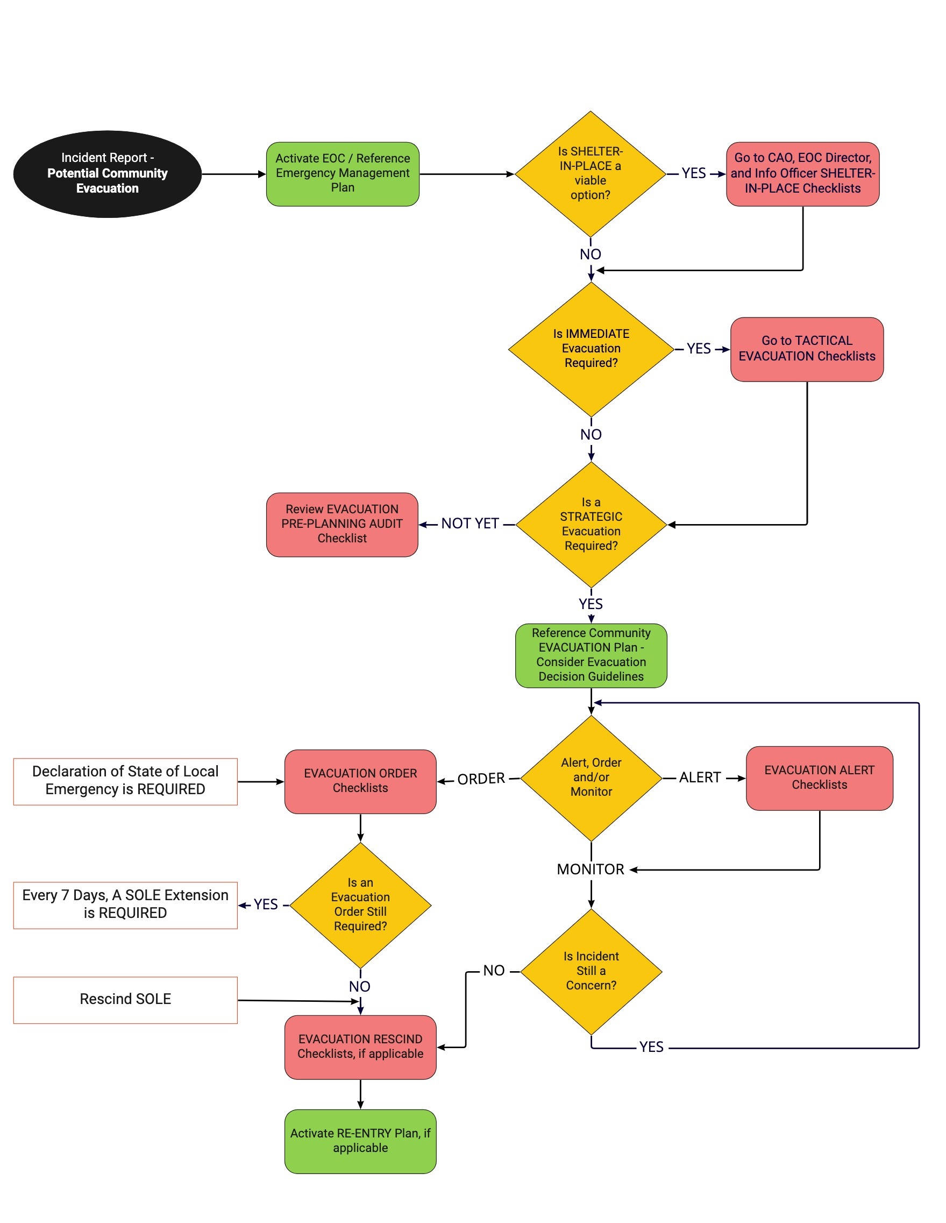

5.0 Evacuation COMMUNITY PARTNER List

- BCEHS (formerly BC Ambulance)
- BC Hydro
- BCWS (seasonally)
- Canadian Red Cross Society
- Regional Transit
- CP Railway
- EMCR
- Fortis
- Local Health Authority
- MoTT to update DRIVE BC & provide Traffic Control
- Neighbouring First Nation Communities
- RCMP
- Regional District North Okanagan
- School District
- Telus

- This partner agency list may vary depending on the incident type, scope, and scale
- Add neighbouring communities, RCMP detachments, regional districts, First Nation communities etc..

6.0 Evacuation Decision Guidelines

Wildfire
Depending on conditions, fire behaviour can be explosive in nature so each decision to evacuate should consider these triggers as well as other prevailing factors at the time. It is best to include fire behaviour modelling and recommendations from the BC Wildfire Service in your decision-making process as well.
Decision making guidelines can include:
- Time for fire to reach community boundary < 48 hours under current & forecast weather conditions AND:
  - Fire is out of control or not contained in next 24 hours AND
  - Fire has the potential to move toward the community

- Time for fire to reach community boundary < 24 hours under current & forecast weather conditions AND:
  - Fire is out of control or not contained in next 6 hours AND
  - Fire has the potential to move toward the community

- Fire is at or inside community boundary AND:
  - Is out of control AND
  - Has potential to threaten community or homes within 24 hours

- Fire is inside community boundary AND/OR immediately threatening homes

Hazardous Materials Spill
Examples of hazmat evacuation triggers could include:
- A sudden unplanned event such as a motor vehicle accident that is in or near the community and/or upwind if there is a plume
- An explosion in or near the community that involves dangerous goods
- Residue from a clandestine drug lab illegally dumped in or near the community

General Method for Calculating Evacuation Triggers
A simple formula that is commonly used for calculating evacuation triggers for all hazards is as follows:

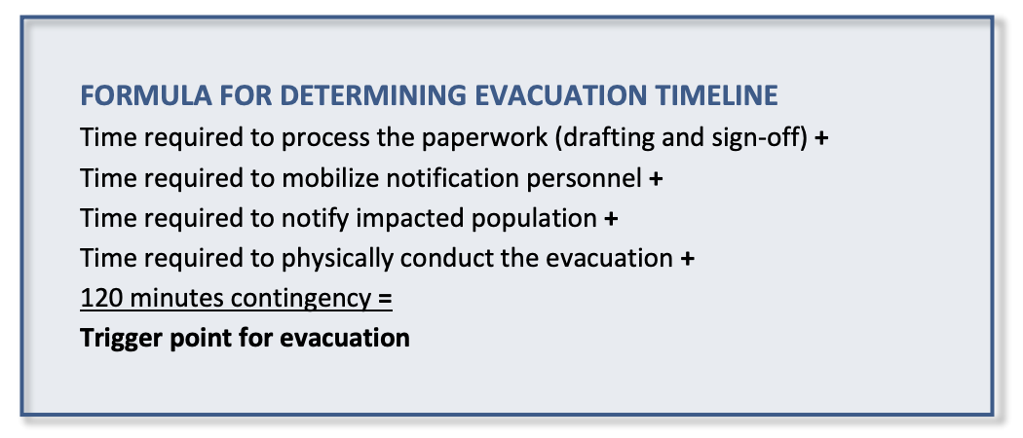

7.0 Sample Evacuation Org Chart

This chart is intended to be a guide to identify what potential functions may need to be filled. Each event will be different. Depending on the type and size of the evacuation, each function may or may not need to be filled and a person can fill more than one function

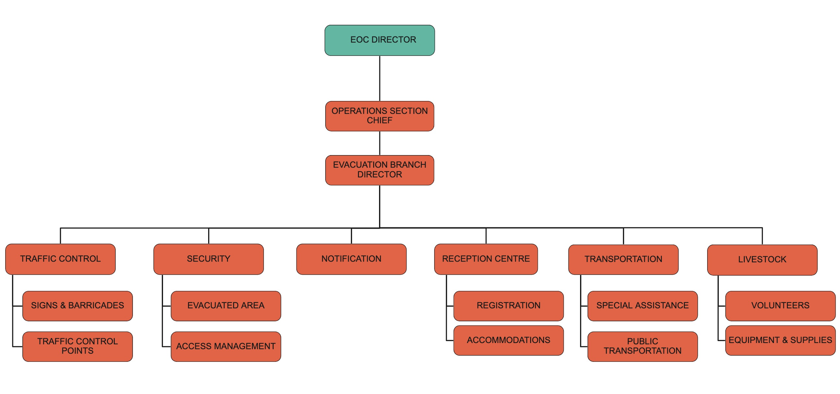

8.0 MAPS
INSERT MAPS HERE

